**DAILY ONLINE ACTIVITIES SUMMARY**

|  |  |  |  |  |  |  |  |  |
| --- | --- | --- | --- | --- | --- | --- | --- | --- |
| **Date:** | 05-06-2020 | | | | | **Name:** | Chethan C K | |
| **Sem & Sec** | Fourth sem section A | | | | | **USN:** | 4AL18CS017 | |
| **Online Test Summary** | | | | | | | | |
| **Subject** | | N/A | | | | | | |
| **Max. Marks** | | N/A | | **Score** | | | N/A | |
| **Certification Course Summary** | | | | | | | | |
| **Course** | Complete Python Bootcamp | | | | | | | |
| **Certificate Provider** | | | Udemy | | **Duration** | | | **2 hr** |
| **Coding Challenges** | | | | | | | | |
| **Problem Statement:**  1: Program to find the repeated character in a string. | | | | | | | | |
| **Status:** completed | | | | | | | | |
| **Uploaded the report in Github** | | | | | yes | | | |
| **If yes Repository name** | | | | | <https://github.com/alvas-education-foundation/chethan_c_k> | | | |
| **Uploaded the report in slack** | | | | | yes | | | |

**Online Test Details: N/A**

**Online Course Details:**

1. Name of course:[Complete](https://olympus.greatlearning.in/courses/10918) Python Bootcamp

Certificate provider: Udemy

The entire session was about the widget and GUI.

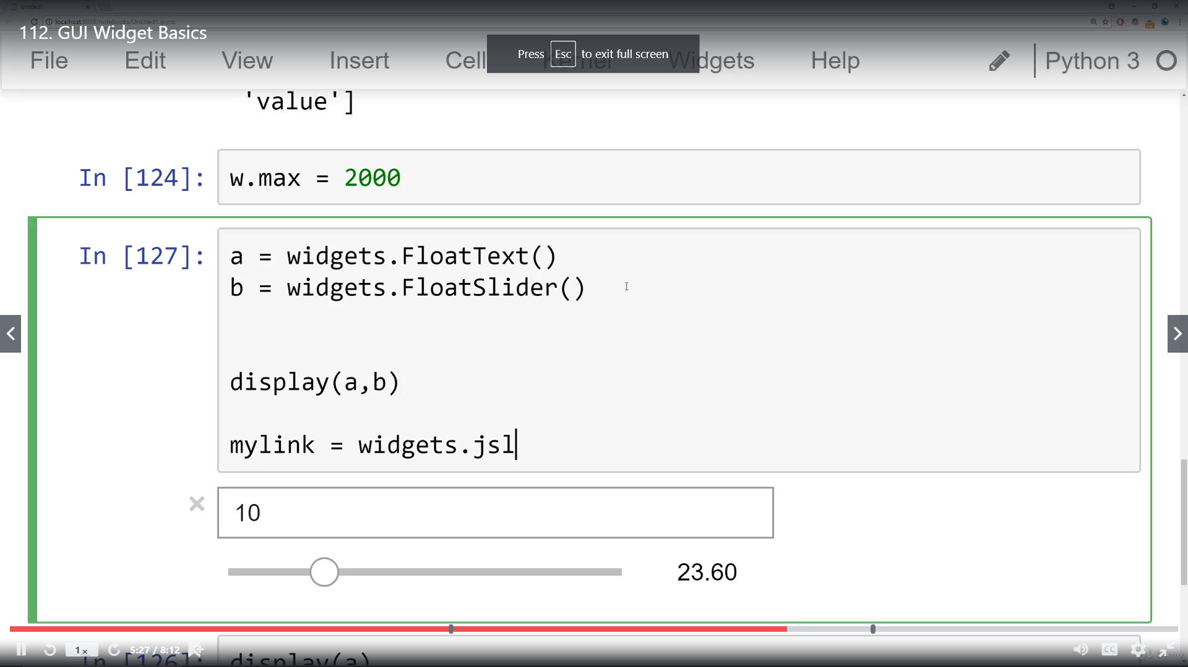

**Online coding:**

Problem 1:Problem to print the repeated characters.